AMBA HW 3

Business Model and Web Design

Spring 2020

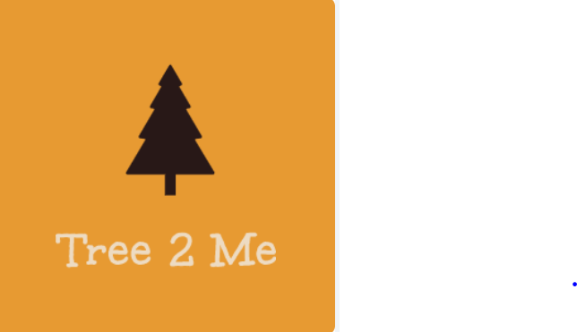

Alex George

ID: 016304013

Due Date: April 16, 2020

**Introduction**

**Website:** <https://silvercookie96.wixsite.com/mysite>

**Business Name:** Tree 2 Me

**Business Model:**  Business to Consumer (B2C)

**Type of Business:** Mobile application, E-commerce

**What is Tree 2 Me?**

Tree 2 Me is a mobile application and desktop website where consumers can search, view, and contact holiday (Christmas) tree providers in their local area. Tree 2 Me integrates local holiday sellers’ trees into an online marketplace designed so customers can find the ideal tree at the most convenient location. Ideally, Tree 2 Me is the “Yelp” of Christmas Tree buying.

**Mission Statement:** To deliver best in class customer satisfaction for the Christmas tree buying process.

**Organizational Goals:** Be the leading provider in customer convenience and customer satisfaction when it comes to purchasing Christmas trees.

**Who is our target market?**

Christmas tree sellers focused on increase customer sales and marketing product offerings to greater local audiences that have been unreached by traditional means.

Customers who celebrate Christmas during the winter holidays and who are looking for a better alternative than the traditional laborious process.

**Core Competencies:**

Provide premium service offerings tailored to Christmas tree providers/users in a desktop application and mobile environment.

Customer satisfaction is of the utmost importance hence why Tree 2 Me provides product pictures and verified customer reviews to give the greatest autonomy to Christmas tree buyers.

**Creativity and Value proposition**

**How different is your business compared with other existing E-commerce businesses?**

Tree 2 Me is the only e-commerce intermediary that specializes in aiding customers to find the ideal Christmas tree in his or her local area. We are an online platform designed to make online selection easier for holiday tree shoppers, this means that Tree 2 Me does not actually sell the trees or hold inventory, we primarily promote businesses and provide services. E-commerce competitors such as Atreetoyourdoor.com and Christmasfarms.com grow trees in house and sell them through their online website where the tree is sent directly to the end consumer through postal delivery carriers. Though our competitors operate in the same market as us, Tree 2 Me has a different vision for the optimal Christmas tree buying experience.

**Service Offerings**

Christmas tree providers can list their organization details along with current product offerings including a written description, type of tree (Noble, Norman, Douglas, Grand Fir, Silver Tip) price, stand price, optional netting, delivery fee, and uploaded picture references.

**How do your company’s products or services fulfill the needs of customers?**

Our services help direct customers to the ideal tree at the most convenient location for no charge at all. At the same time, we are promoting local Christmas tree providers and increasing their engagement with the local community.

**Why should the customer buy from you? Hard to copy, not matched by rivals**

Customers should use our services over competitors due to our superior *value propositions*. Holiday Tree Businesses should use our services since they will receive more exposure and visibility, increase network traffic, heightened user engagement, and ability to use analytical tools to view customer traffic. Furthermore, potential Christmas tree customers should use our services over competitors because our platform creates more informed buyers through price comparison, product description, product pictures, and verified reviews.

**Revenue model**

**How does your company earn revenue, generate profits?**

Tree 2 Me is free for all customers looking for a Christmas tree, however, companies looking to increase their market visibility will paying a fair fee for our services. Tree 2 Me generates revenue off a subscription plan which holiday tree selling organizations can choose from one of two plans:

**Yearly plan**: 12 months at a cost of $150/ month. ($1,800 annually)

**Seasonal plan**: 3 months (October – December) at $700/ month. ($2,100 annually)

**How is your revenue model sustainable?**

Seeing how we take on no additional cost having one more tree provider under our platform, the marginal or incremental cost of taking on one more customer is almost non-existent. Our model is sustainable if we cover our breakeven costs. There are 1,250 vendors in just Oregon alone if we are able to capture just a small percentage of those vendors, we will remain sustainable. Since we require no inventory or physical location our fixed costs will be low and shouldn’t have a problem remaining profitable.

**Market opportunities and competitive advantages**

**What market space do you intend to serve and what is its size.**

Tree 2 Me operates in the North American Real Christmas Trees market. There are approximately 25-30 million Real Christmas Trees sold in the U.S. every year accounting for $2 Billion annual sales.

**Existing Competition**

The existing competition, when it comes to e-commerce Christmas tree sales, are organizations such as Home Depot, Walmart, Amazon, A Tree to Your Door, and Christmas Farms.com. Retail chains like Home depot and Walmart have adopted a broad differentiation strategy curtailing to customer convenience, product reliability, and low-cost tree pricing. E-commerce retailors like A Tree to Your Door is adopting a low-cost strategy model where they underprice competitors and attract price-sensitive buyers by operating solely online. They can cost cut their competitors through their minimal inventory, logistical and managerial costs.

**What is your niche market if any?**

Within the North American real Christmas tree market, we are the only company to promote local sellers through an online marketplace. Consumers have greater autonomy over his or her tree purchasing decision through us up to date detailed product offerings.

**Market strategy**

**How do you plan to promote your products or services to attract your target audience?**

Social media accounts are free of charge and can be one of the best tools to curve high marketing costs (Facebook, Instagram, YouTube, Twitter, LinkedIn). Tree 2 Me will take advantage of legacy advertising channels such as print news and cable T.V. to reach the Baby Boomer generation, as many continue to use these mediums as their primary forms of entertainment.

**What special advantages does your firm bring to the marketplace to be competitive?**

Here at Tree 2 Me our primary importance is customer satisfaction which incorporates throughout our value chain. To enhance buyer satisfaction and customer loyalty we established customer comments and feedback reviews. We outcompete rivals in finding the ideal tree for you. While other companies have the ability to deliver trees, they lack the ability to post detailed information, up to date pictures, products and sellers near you. Few rivals are following a similar differentiation approach and we are confident in our ability to adapt to market conditions.

**Competitive Strategy**

We operate a focused differentiation strategy that concentrates on a real Christmas tree buyer on which we outcome rivals when it comes to finding the right tree in the fastest amount of time. We will stay committed to serving the niche of finding the ideal Christmas tree in the fastest amount of time better than rivals.